**React Context vs Ref**

**React Context (Functional Components)**

React Context provides a way to share values like themes, user authentication status, or any other global state across the component tree without explicitly passing props through each level.

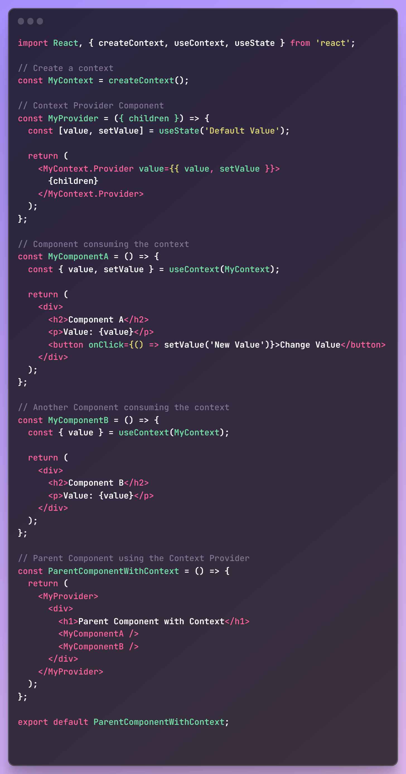

In this example, `MyProvider` is used to wrap the components that need access to the shared context. Both `MyComponentA` and `MyComponentB` can access the shared state (`value`) using the `useContext` hook.

**References (Functional Components)**

React References (refs) are used to get a reference to a DOM element or a class component instance. They are often used to interact with the DOM imperatively.

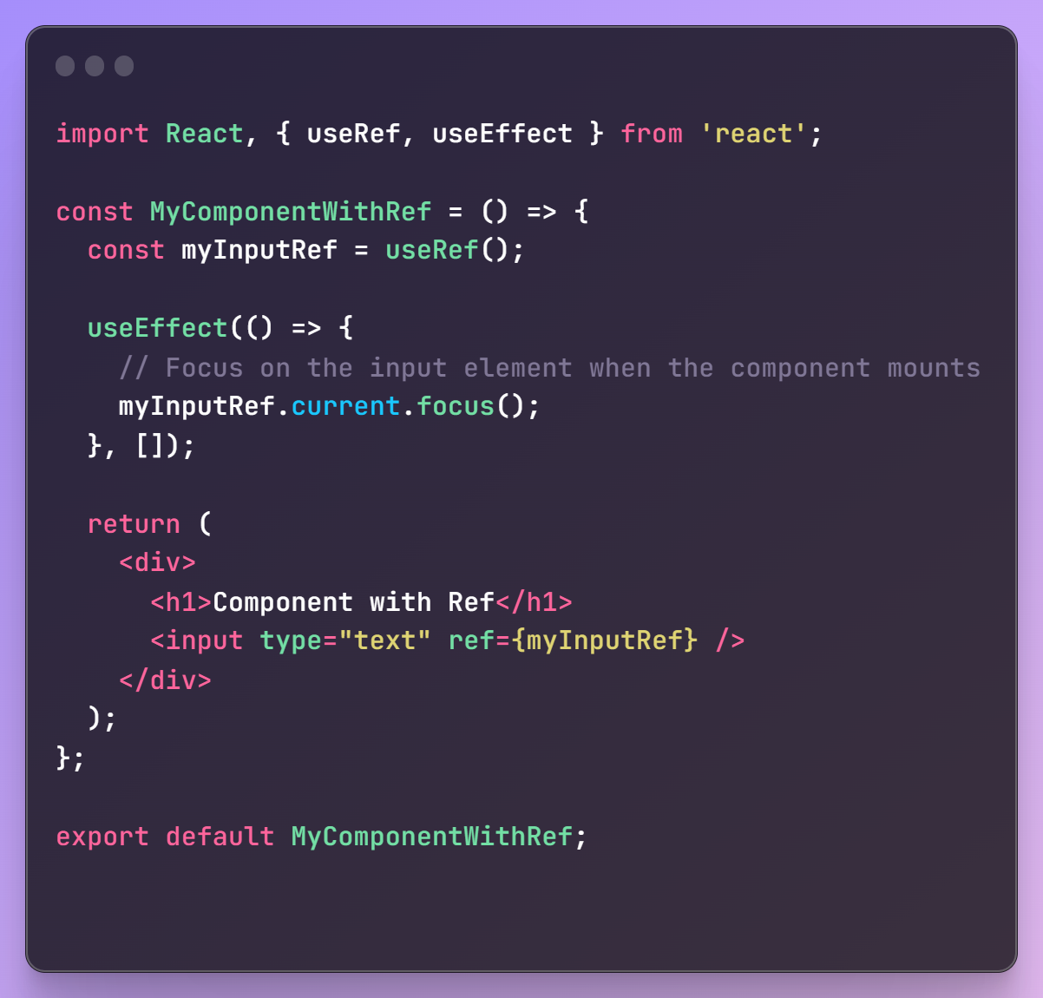

In this example, `useRef` is used to create a reference to the input element. The `useEffect` hook is then used to focus on the input element when the component mounts. This is just a simple use case, and refs can be used for various purposes, such as accessing and modifying DOM elements directly.

Remember that while context is mainly used for sharing state across components, refs are used for interacting with the DOM. They serve different purposes and can be used together when needed.Here are some more examples of methods and properties you can use with React refs, particularly for DOM elements:

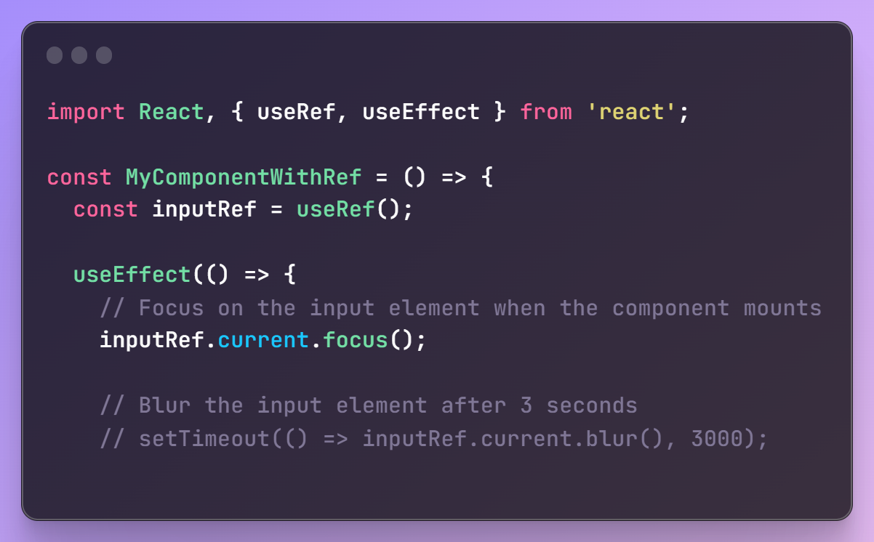

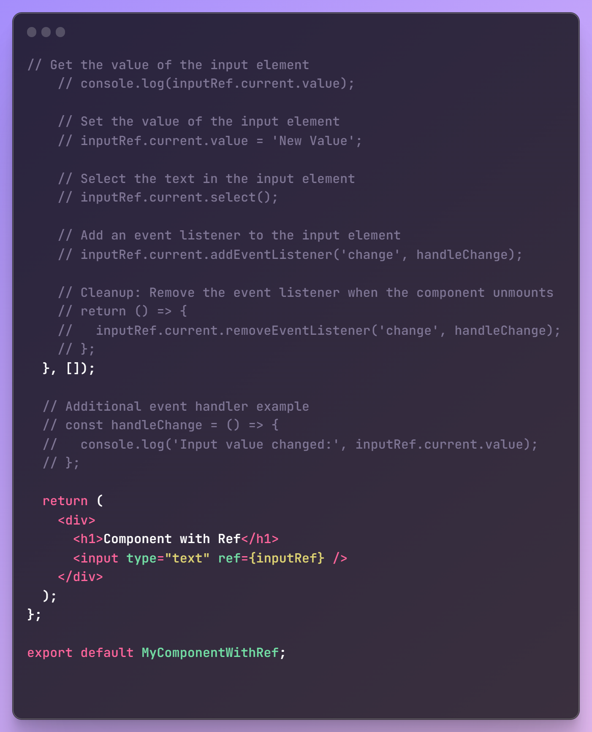

**Exercise:**

Lets say I want a default value in the input but the I want to erase the default if user inputs it's own and then the value to what user types. For example initially as the page loads input field should contain "XYZ". But if User selects the input field, we need to select the default "XYZ" and overwrite it whatever the user gives. If nothing is given input, input field border must be red indicating this field is required (This can be handled by HTML)

Solution

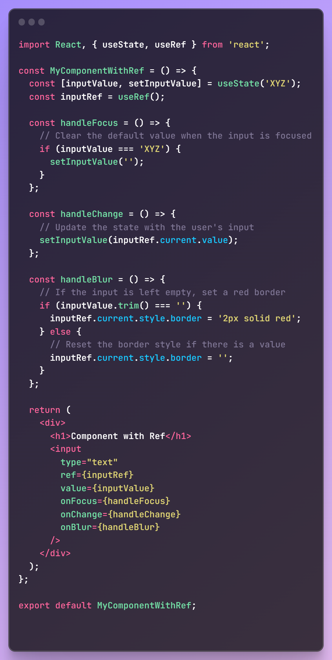

Doubt: What s onBlur event?

The onBlur event in React is a synthetic event that occurs when an element loses focus. In the context of a form or an input field, the onBlur event is triggered when the user clicks outside the input field after interacting with it. This is in contrast to the onFocus event, which occurs when an element gains focus.

Here's a brief explanation of the onBlur event:

Event Type: Synthetic Event

Triggered when: The associated element loses focus, often after a user interacts with it (e.g., clicking inside an input field and then clicking outside of it).

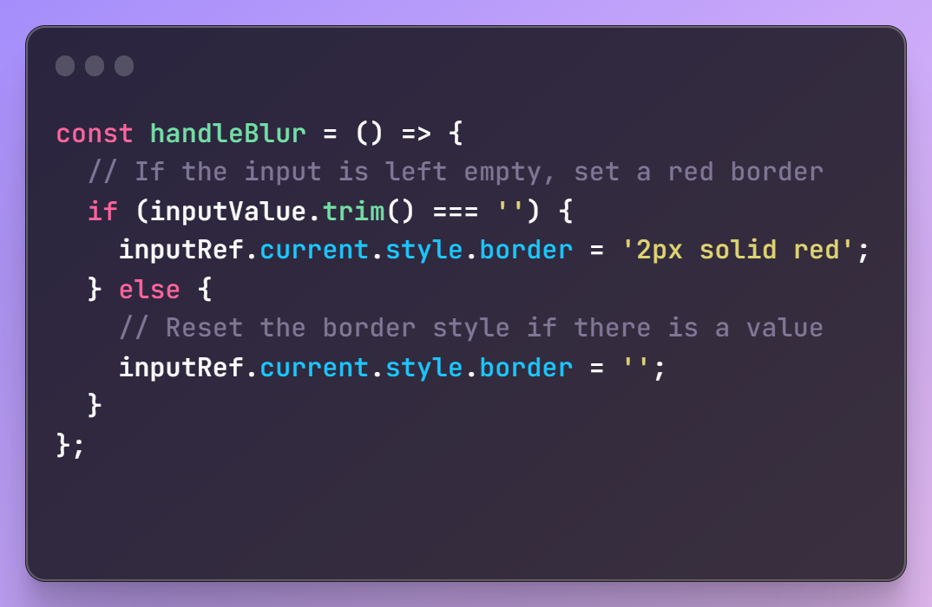

The handleBlur function is called when the onBlur event occurs on the input field. It checks if the input is empty, and if so, it sets a red border to indicate that the field is required. If there is a value, it resets the border style.

In summary, the onBlur event is useful for performing actions when an element loses focus, allowing you to handle various scenarios, such as validation, user feedback, or updating state based on the user's interaction with the element.